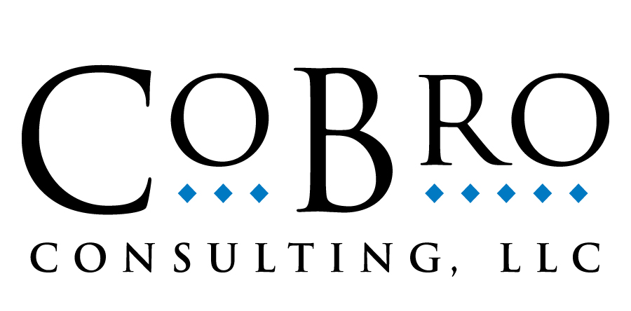

CoBro Consulting Services and
Comprehensive Program Assessment System (Compass) Program Information Form
Please complete one form for each program for which you are seeking services.

If you have a grant program for which you are interested in using CoBro Consulting Services, the Compass System, or CompassMatch, please complete the following form. Information provided in this document will help us to determine how to accommodate your database management and program evaluation needs.

I. Contact Information
Program Director/ Manager contact information:
Name: Title: Organization/Institution:
Mailing Address: City/State/Zip:
Physical Address (if different from above): City/State/Zip:
Phone: Email:

Additional contact, if applicable:
1. Name: Title: Organization/Institution:
Phone: Email:

II. Evaluation and Database Management System Needs
Do you currently have/use a database management system? Yes No
Do you currently have an evaluator? Yes No

Please indicate the services for which you would like a price quote. (Mark all that apply.)

Comprehensive Program Assessment System (Compass): Data management and reporting (student tracking) system
CompassMatch: Matching funds (in-kind) contribution management and reporting system
Surveys (form design, data processing, analysis, and results report development)
Biennial evaluation and results report development
Evaluation reports during non-biennial years (Choose one):
Full annual evaluation report (similar in scope to biennial report)
Summary progress report (one-page both sides graphic/narrative document).
Data analysis to examine progress toward established grant objectives for Annual Performance Report (APR)
Assistance with evaluation-related narrative sections for Annual Performance Report (APR)
Other, please specify.

III. General Program Information
Name of federal grant initiative (e.g., GEAR UP, TRIO, CACG):
Official name of program:
Institution or organization administering the grant:
Primary location of program:

IV. Specific Program Information
*Denotes fields applicable to GEAR UP programs only

Proposed - If proposed, have you received notification of your award? Yes No
If no, when do you expect notification? Expected program start date:

Existing - If existing, year awarded: Duration of program (number of years granted):
*Type of Grant: State-Wide Partnership Other
*Grant Model : Cohort Priority Combination
If cohort model, how many cohorts will you serve?
Number of years of back data:

Please provide approximate figures for the following:

Total number of students you will serve each year (all years) :
Year 1 | Year 2 | Year 3 | Year 4 | Year 5 | Year 6 | Year 7

Total number of participating schools (all years):
Elementary Schools | Middle Schools | High Schools | Postsecondary Institutions

Total number of participating districts (all years):
Districts | Independent/Charter Schools (if not included in district count)

Do you have access to academic data? Yes No
- If Yes, for how many of your districts? For out of a total of districts.
- If No, please describe the availability of data?
- Do you have access to data collected by your State Longitudinal Data System? Yes No
Do you have a timeline for implementation of our services?

Please describe any additional program features you feel are unique to your grant.

Do you have any specific requirements or requests for database management or evaluation services?

Do you have any additional information about this program that you feel would be useful for us to know?

V. Survey Information
If you are not requesting information about our survey services, please skip this section.

Please indicate the survey needs you would like included in your cost estimate (mark all that apply):

Who will be surveyed? | Students | Parents | Staff/Teachers | Other¹ (specify: )
Survey Language(s) Required²
English
Spanish
Other (specify: )
Survey Method(s) Required
Paper
Online
Survey Frequency Required
Twice a year
Once a year
Once every two years
Other (specify: )
Survey Results Reports
One report per program
One report per region
One report per school district
One report per school
¹Examples of Other surveys that may be pertinent: comparison group students and/or parents, program partner organizations/individuals.

Note: CoBro Consulting will provide forms in English and Spanish, and will rely on your local translator to provide additional translations. We will work with the translator to ensure these forms can still be scanned/processed by CoBro.

Please describe any other survey services you are requesting, if applicable.

Thank you for your interest in our services!
Please submit this completed form to: Carina Davio at cdavio@cobroconsulting.com.

